**韩昊辰 20214272 001班**

**Week 8**

**1, My learning**

* 1. class notes

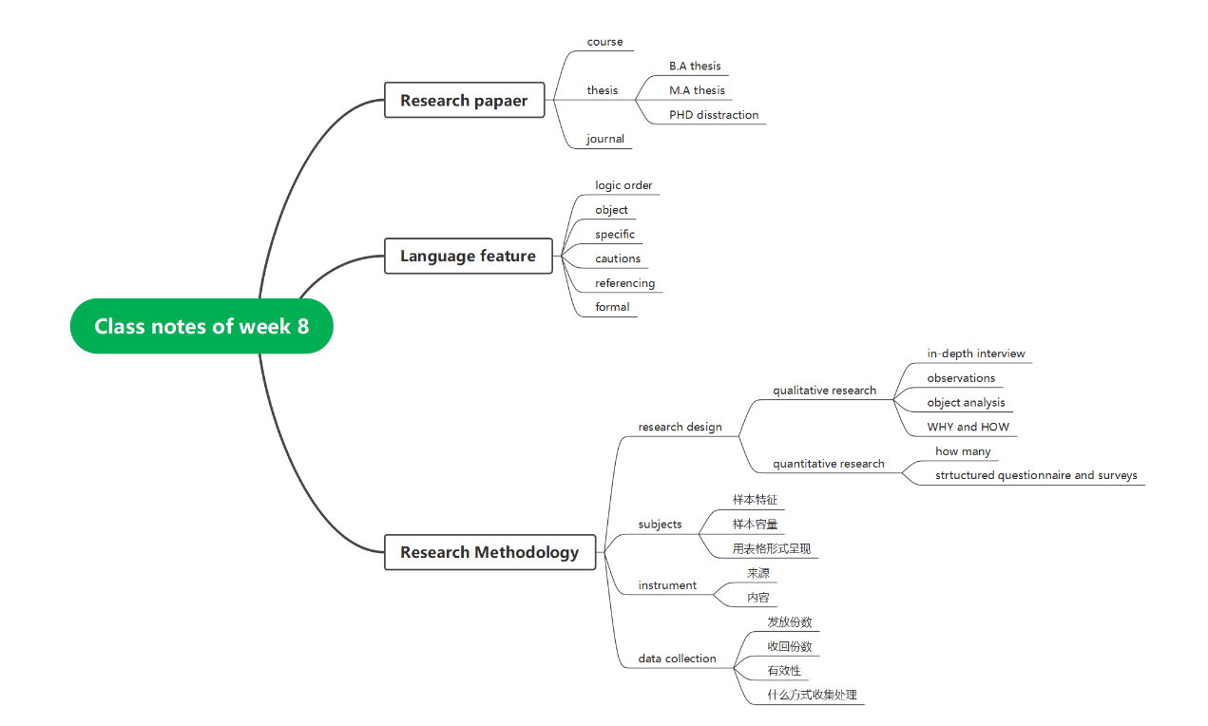

* 1. Write Chapter 2 Research Methdology

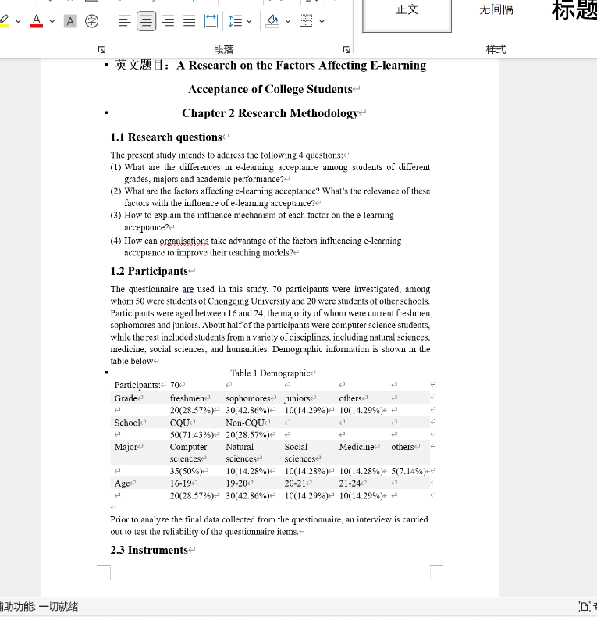

**2, Learning outcomes**

* Learn the writing steps of research methodology
* Learn the writing method of the research methodology of predecessors, and know the precautions
* Exercise writing ability

**3, My behavior and attitude**

**1）Out of Class**

1.1 Autonomous learning

1.1.1Online

* Listen to Ted

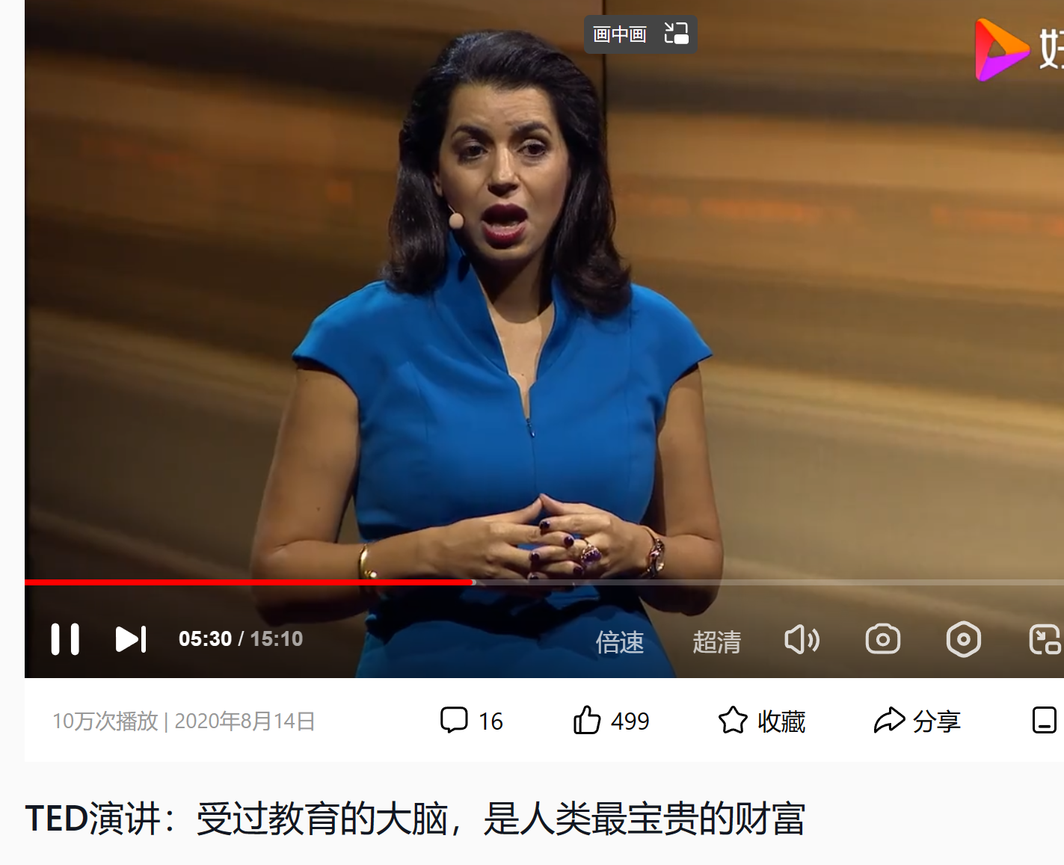

* Read related literature

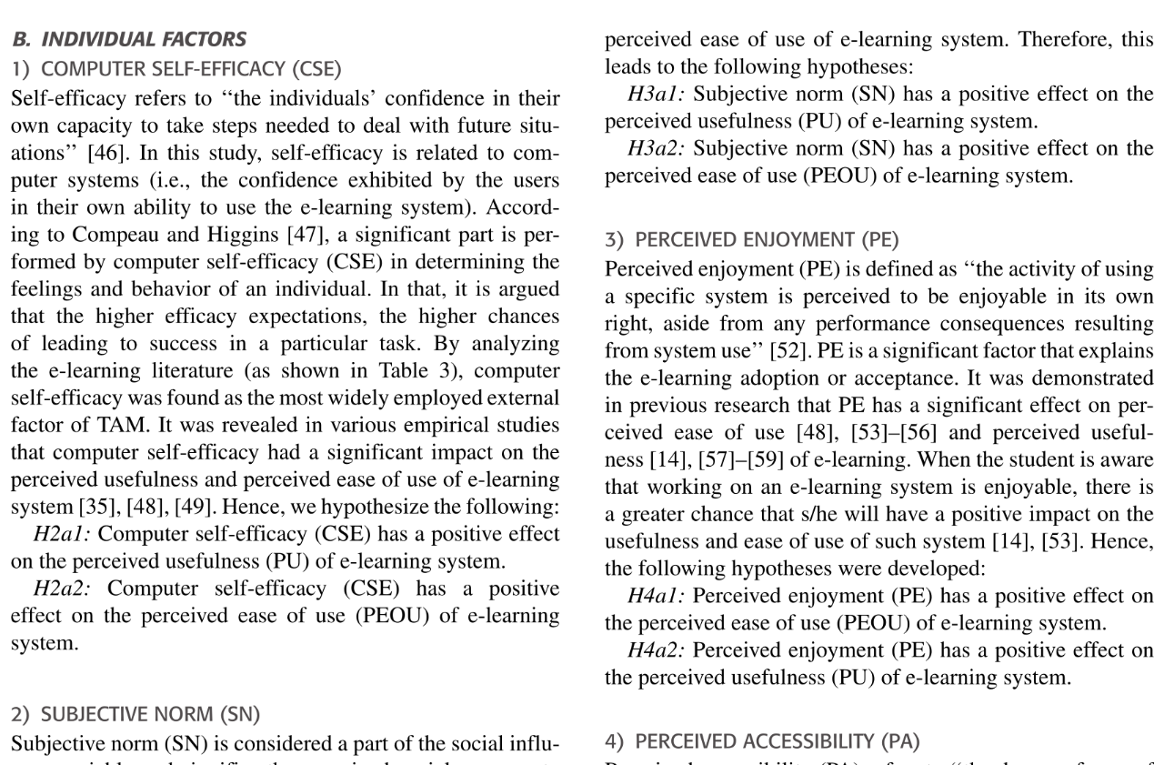

* + 1. Offline

Mainly do online English Study

* 1. Homework

Write research methodology

**4．Improvement**

**4.1** Autonomous learning

* Improve listening
* Vocabulary

**4.2** Homework

* Read faster

**Week 9**

**1, My learning**

* 1. class notes

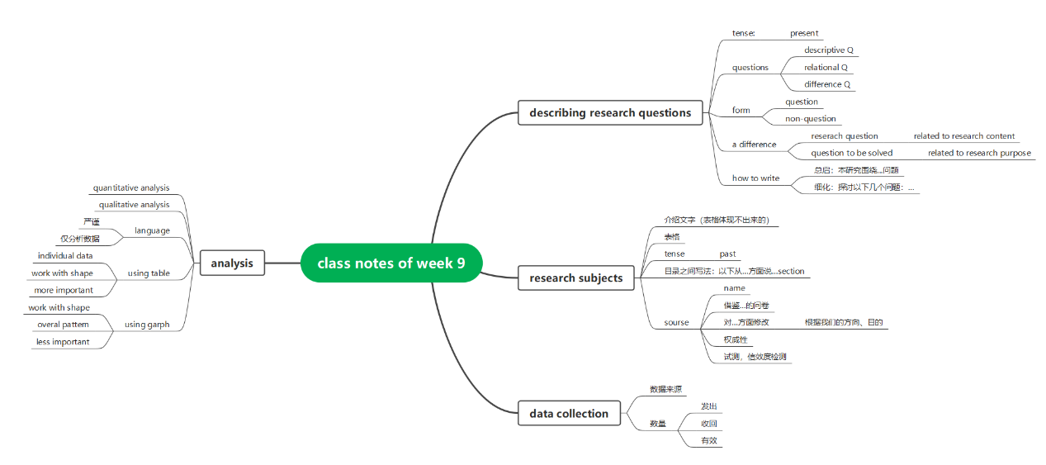

* 1. Issue the questionnaire

 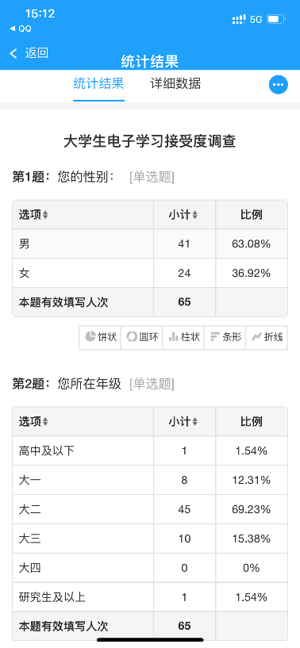

* 1. Analyze the data

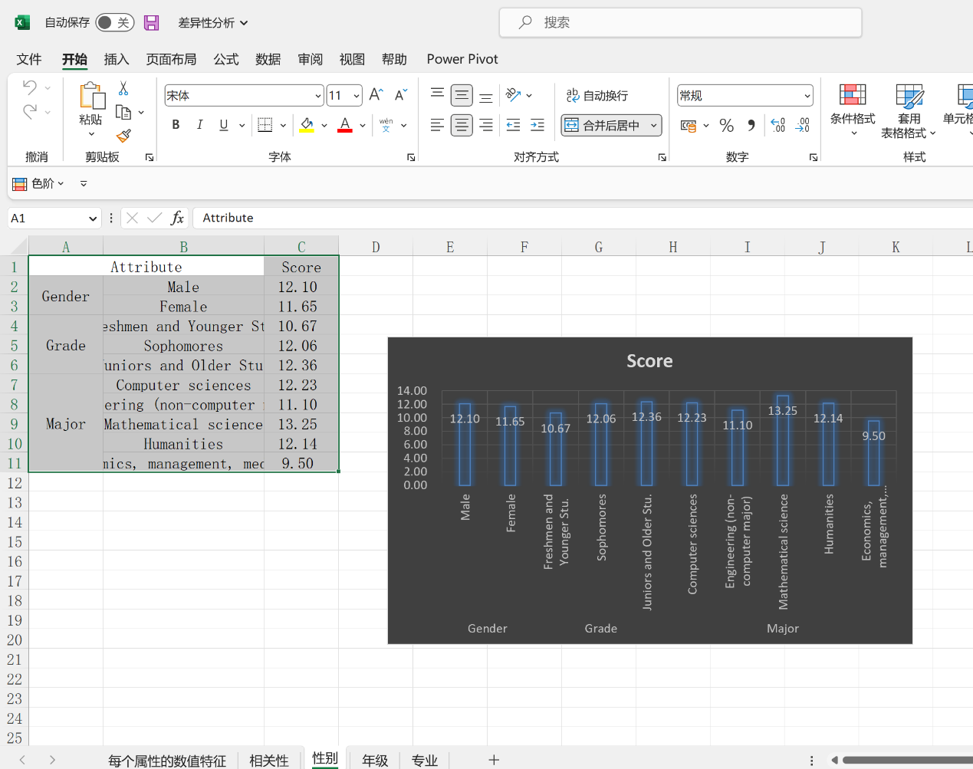

* 1. Write chapter 3 data analysis

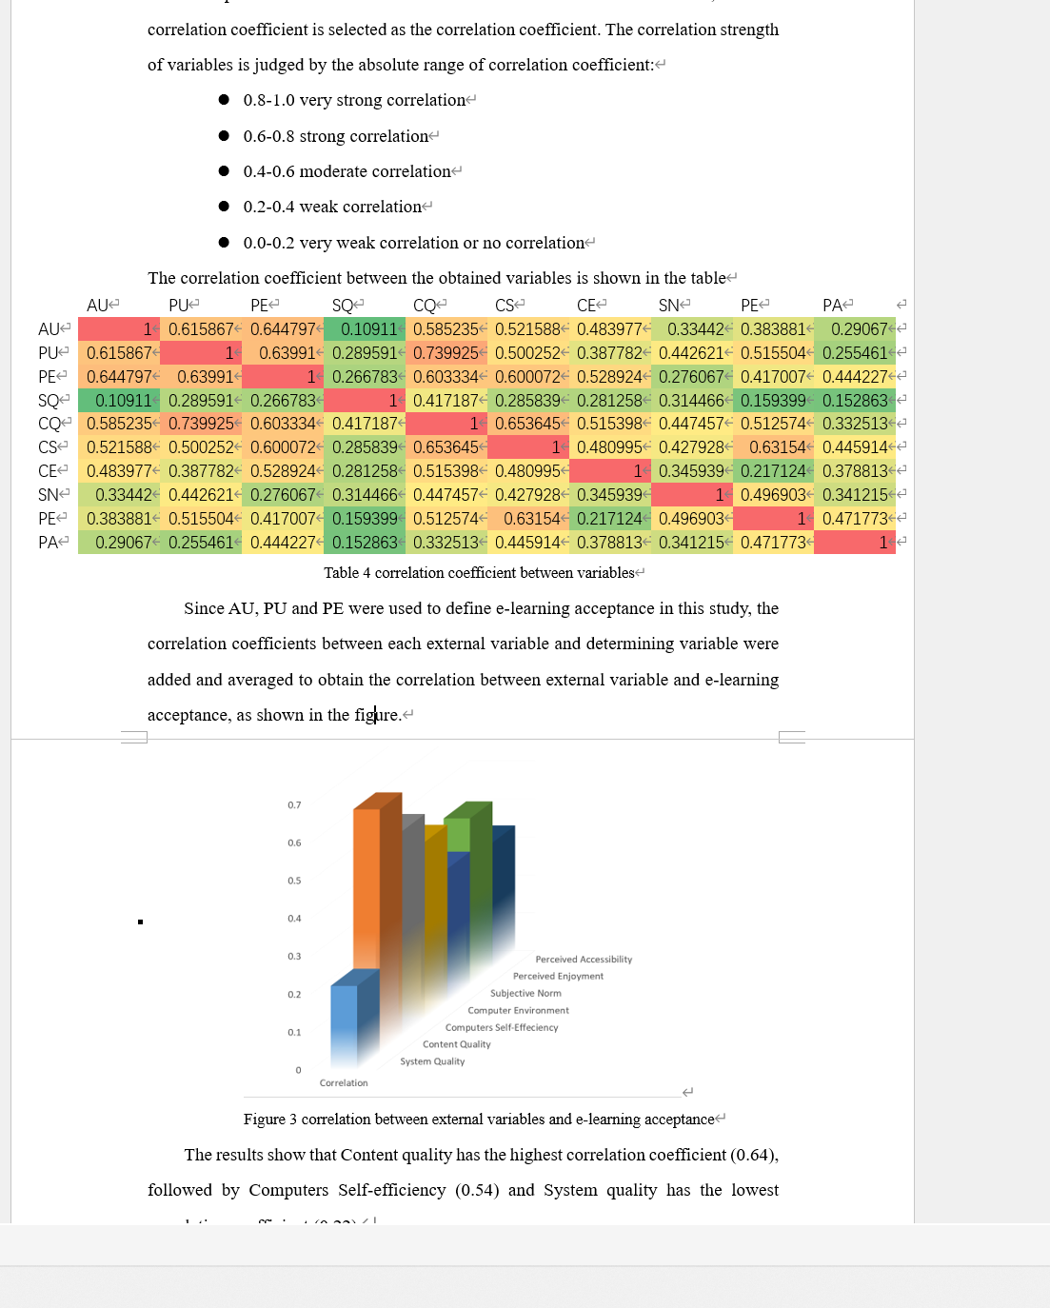

**2, Learning outcomes**

* Learn to write data analysis in the correct format
* Correlation analysis was used to process the information collected from the questionnaire

**3, My behavior and attitude**

**1）Out of Class**

1.1 Autonomous learning

1.1.1Online

* Listen to Ted

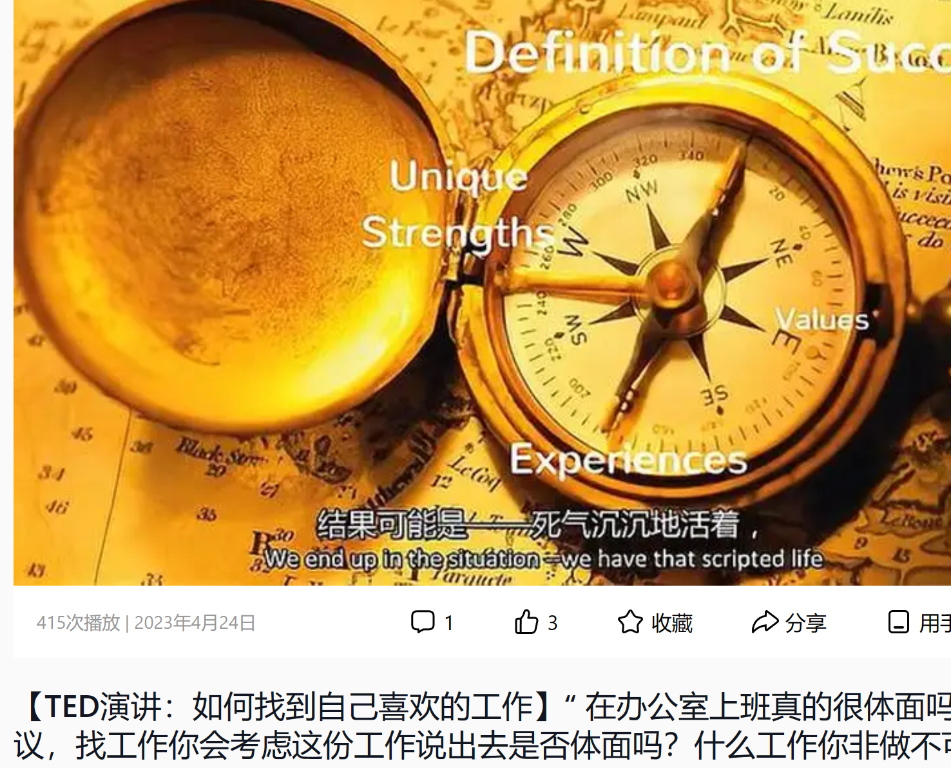

* Watch English movies- Three Billboards Outside Ebbing, Missouri（电影名）

1.1.2 Offline

* Read national geography

1.2 Homework

* Questionnaire issued
* Collect the results
* Analyze the data
* Write the result in the research report

**2）In Class**

2.1 Individual performance

* Take notes
* Answer questions

**4．Improvement**

**1）Out of Class**

1.1 Autonomous learning

* Improve listening
* Vocabulary

1.2 Homework

* Read faster

**Week 10**

**1, My learning**

* 1. class notes

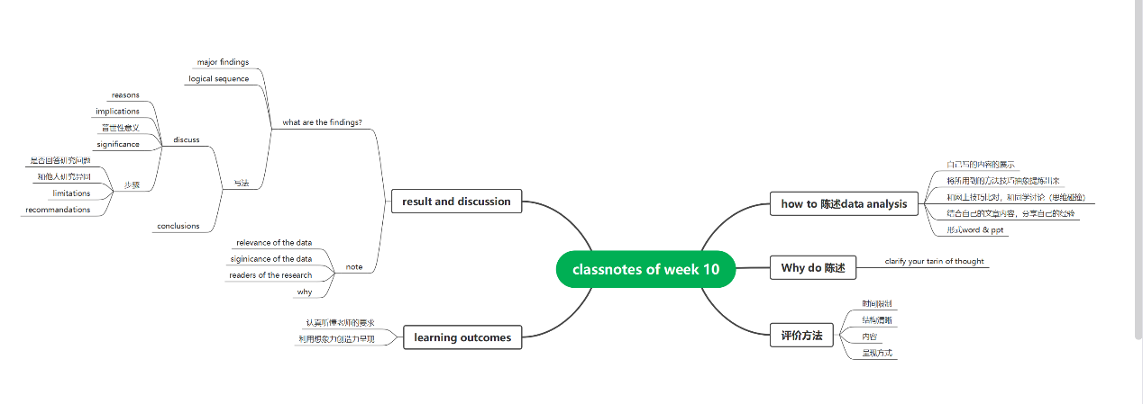

* 1. Write Result and discussions part of my research

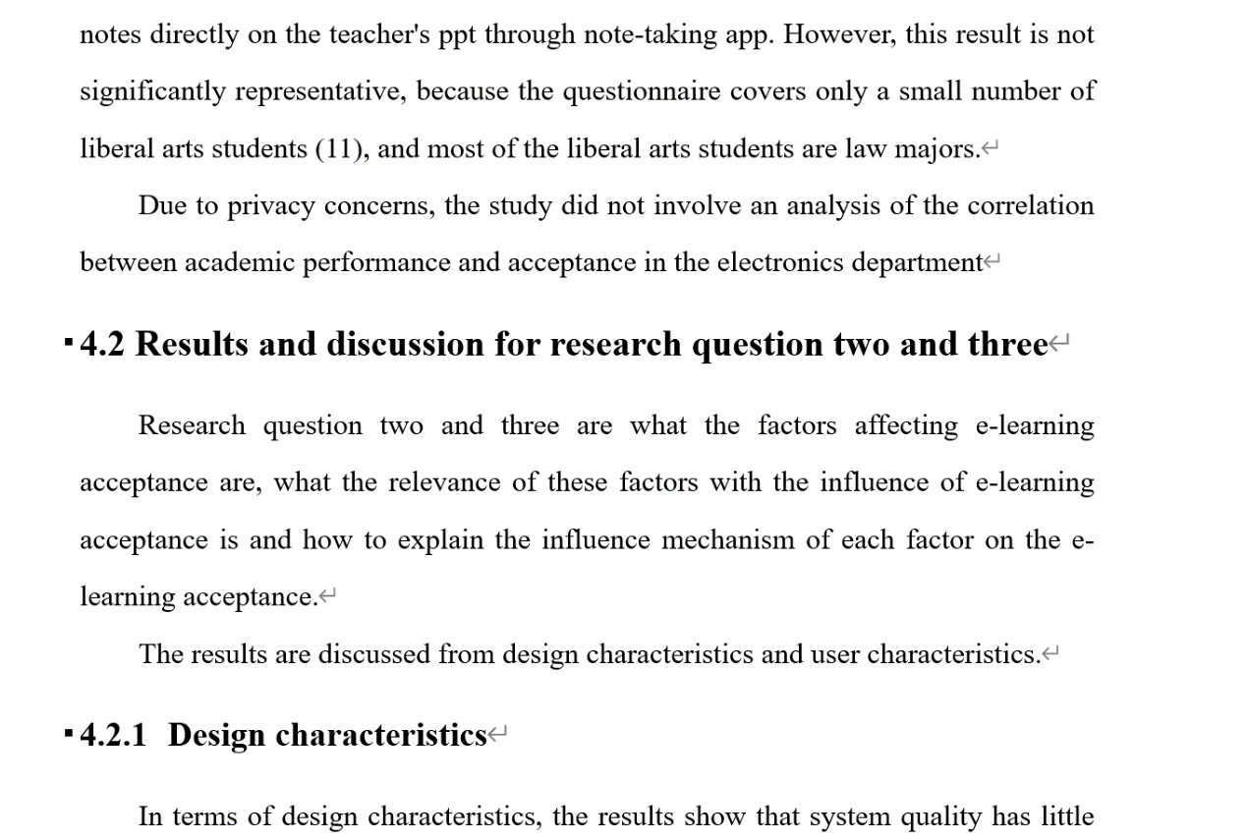

**2, Learning outcomes**

* Learn to write result and discussion section. The contents of the introduction section learned in class were written into my article
* Do the assignment before you know what the teacher wants
* Use imagination and creativity to complete the task assigned by the teacher

**3, My behavior and attitude**

**1）Out of Class**

**1.1 Autonomous learning**

1.1.1Online

* Listen to Ted

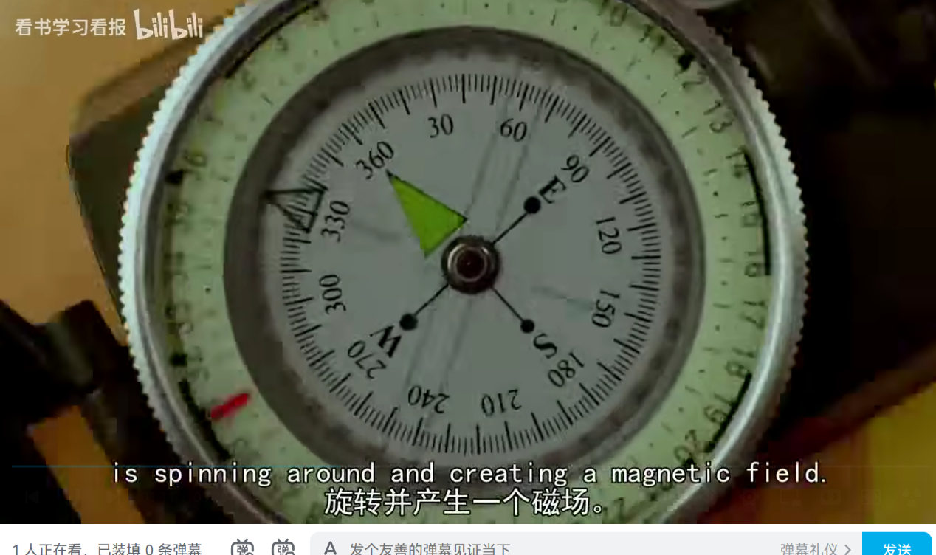

* Read Sallum’s article about the research on the students acceptance of the school learning system.
* Read National Geography

**1.2 Homework**

Result and discussions section writing

**2）In Class**

2.1 Individual performance

* Take notes
* Answer questions

**4．Improvement**

**1）Out of Class**

1.1 Autonomous learning

* Improve listening
* Vocabulary

1.2 Homework

* Read faster